1)Simplest

Compare the current frame with the previous one

Advantages:

Simple to implement

Useful in video compression when you need to estimate changes and to write only the changes, not the whole frame.

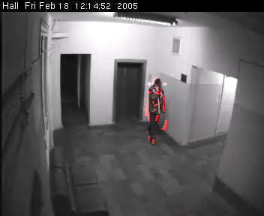

Disadvantages:

Since most cameras produce a noisy image, we'll get motion in such places, where there is no motion at all. To remove random noisy pixels, we can use an Erosion filter

If the object is moving smoothly we'll receive small changes from frame to frame. So, it's impossible to get the whole moving object. Things become worse, when the object is moving so slowly, when the algorithms will not give any result at all.

2)Background creation

The most efficient algorithms are based on building the so called background of the scene and comparing each current frame with the background.

At the beginning, we get the first frame of the video sequence as the background frame. And then we'll always compare the current frame with the background one. Our approach is to "move" the background frame to the current frame on the specified amount (1 level per frame). We move the background frame slightly in the direction of the current frame - we are changing colors of pixels in the background frame by one level per frame.

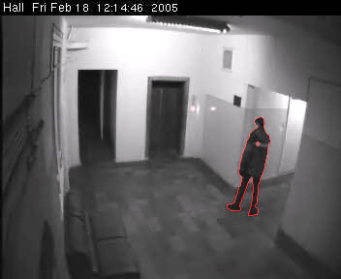

Advantages

It's possible to compare the current frame not with the previous one but with the first frame in the video sequence. So, if there were no objects in the initial frame, comparison of the current frame with the first one will give us the whole moving object independently of its motion speed.

Disadvantages:

If there’s an object in the first frame and then it’s gone, motion will be detected. To avoid this,initial frame should be renewed.

Pixellated Background Creation:

Another approach involves taking an original frame and grayscale version of it and the background frame and then applying Pixellate filter to the current frame and to the background.

So, we have pixellated versions of the current and background frames. Now, we need to move the background frame towards the current frame as we were doing before.

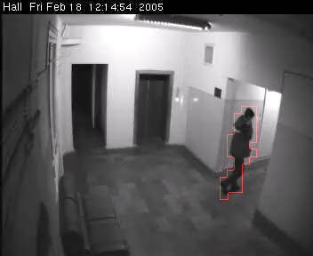

Advantages:

Performance optimization possible

Disadvantages:

Boundaries are not accurate.

|  |  |  |
| --- | --- | --- |
| Basic Blank Background | Previous - current | Pixel |
| Comparison between the current frame and the first frame with empty background. | Comparison between the current frame and the previous frame. | Comparison between pixelated current frame and the background frame. |
| 1. Set the first frame as the background frame. 2. Compare the current frame with the background frame. 3. Move the background frame to the current frame on the specified amount. Move the background frame slightly in the direction of the current frame - changing colors of pixels in the background frame by one level per frame. 4. Detect regions where the two frames differ, using difference or threshold filters. 5. Image with white pixels on place where the difference is present on the specified threshold value. 6. Count the pixels. 7. If the number of pixels are greater than a predefined value then the motion is detected. | 1. Detect regions where the two frames differ, using difference or threshold filters. 2. Image with white pixels on place where the difference is present on the specified threshold value. 3. Count the pixels. 4. If the number of pixels are greater than a predefined value then the motion is detected. | 1. Set the first frame as the background frame. 2. Apply Pixellate filter to both the frames. 3. Compare the current frame with the background frame. 4. Move the background frame towards the current frame. 5. Detect regions where the two frames differ, using difference or threshold filters. 6. Image with white pixels on place where the difference is present on the specified threshold value. 7. Count the pixels. 8. If the number of pixels are greater than a predefined value then the motion is detected. |
| Advantages:  Simple to implement  Useful in video compression when you need to estimate changes and to write only the changes, not the whole frame. | Advantages  It's possible to compare the current frame not with the previous one but with the first frame in the video sequence. So, if there were no objects in the initial frame, comparison of the current frame with the first one will give us the whole moving object independently of its motion speed. | Advantages:  Performance optimization possible |
| Disadvantages:  Since most cameras produce a noisy image, we'll get motion in such places, where there is no motion at all. To remove random noisy pixels, we can use an Erosion filter  If the object is moving smoothly we'll receive small changes from frame to frame. So, it's impossible to get the whole moving object. Things become worse, when the object is moving so slowly, when the algorithms will not give any result at all. | Disadvantages:  If there’s an object in the first frame and then it’s gone, motion will be detected. To avoid this,initial frame should be renewed. | Disadvantages:  Boundaries are not accurate. |

ALGORITHM:

1. Capture the image of the empty background ( pool table without balls ).
2. Reduce noise from the image.
3. Apply edge detection algorithm.